What Is HPV (Human Papilloma Virus)?
HPV, or Human Papilloma Virus, is a virus from the papillomavirus family that affects human skin and the moist membranes that line the body, such as the throat, mouth, feet, fingers, nails, anus and cervix. There are over 100 types, of which 40 can affect the genital area. Most known HPV types cause no symptoms to humans. Some, however, can cause verrucae (warts), while a small number can increase the risk of developing several cancers, such as that of the cervix, penis, vagina, anus and oropharynx (oral part of the pharynx - throat cancer).
According to recent studies, HPV infection can also raise cardiovascular disease risk.
The HPV 16 and 18 strains, which are known to cause nearly all cases of cervical cancer, also raise the risk of developing oropharyngeal (throat) cancer.
According to a study published in JAMA in January 2012, men are more susceptible to oral HPV infections than women.

HPV Genital Infection
Genital human papillomavirus is the most common STI (sexually transmitted infection), according to the CDC (Centers for Disease Control and Prevention), USA. The over 40 types that can infect the genital areas, can affect males and females - they can also infect the throat and mouth.
The majority of HPV infected people are unaware, because they have no signs or symptoms.

Most HPV infections in young females are temporary, but not all..
In the majority of cases, infected young females are not infected for long and there is no long-term consequence. The CDC says that over 70% of young female infections clear up within 12 months, while 90% do so within 24 months.
However, in between 5% to 10% of cases, the infection persists. Persistent long-term HPV infection raises the risk of developing precancerous lesions of the cervix - these can eventually, over a period of five to ten years, develop into cervical cancer. During this period, the progress can be treated and reversed with treatment for the pre-cancerous lesions. In some cases, treatment can lead to loss of fertility. However, in the majority of cases, cancer can be prevented.

What are the signs and symptoms of HPV infection?
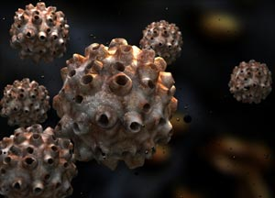
Digital concept image of HPV / human papillomavirus.
In the majority of cases, HPV infection has no noticeable signs or symptoms. As mentioned earlier, in 90% of cases the body's own immune system destroys all the HPVs within 24 months. It is impossible to tell who might go on to develop health problems, including cancer.
Certain HPV types may cause genital warts in both males and females. In a small percentage of cases, patients may develop throat warts (RRP recurrent respiratory papillomatosis).
Some HPV types can alter the structure of cells in the body, which eventually can become cancerous, causing cervical cancer, among others.
The HPV types that cause genital warts are different from the cancer-causing ones.
There are at least 120 types of HPVs. Types 16, 18, 33, 35, 45, 51, 52, 56, 58, 59, 68, 73, and 82 can cause cancer - they are carcinogenic and sexually transmitted; they may eventually develop into:
- Cervical intraepithelial neoplasia (CIN) - cervical cancer

- Penile intraepithelial neoplasia (PIN) - penile cancer. Half of all tumors of the penis, including malignant ones, are linked to the most ordinary forms of sexually transmitted HPVs. (Link to article)

- Anal intraepithelial neoplasia (AIN) - anal cancer
Below is a list of HPV virus types and what signs and symptoms or diseases they are linked to:
- 2, 7 - Common warts. Rough, raised bumps that generally affect the fingers, hands and around the nails. In the majority of cases their only problem is their appearance. However, they may sometimes bleed; some patients may experience pain, but this is unusual.

- 1, 2, 4, 63 - Plantar warts. Small lesions that appear on the soles of the feet; they usually look like a cauliflower, with very small hemorrhages (petechiae) under the skin. When scratched they may bleed. Patients may feel pain when walking or standing. They can be similar to corns or calluses.
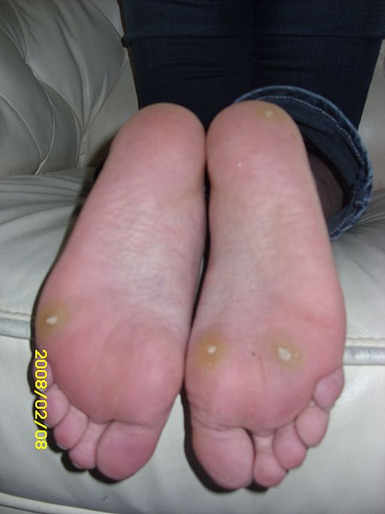
When standing or walking, Plantar Warts can be extremely painful

- 3, 10, 8 - Flat warts. Slightly raised, flat-topped lesions which are darker than the skin around them. They may appear on the knees, elbows, wrists, hands, neck or face. Young adults, teenagers and younger children are usually affected.

- 6, 11, 42, 44 and some others - Anogenital warts. Small, flat cauliflower-like bumps, some may have stem-like protrusions. In females, the warts will usually appear on the vulva, but may also be found in the vagina, on the cervix, and near the anus. In males, they may appear on the penis, around the anus, and on the scrotum. They are rarely painful and do not typically cause discomfort.

- 6, 16, 18, 31, 53, 58 - Anal lesions

- Genital cancers
- 16, 18, 31, 45 - Highest risk
- 33, 35, 39, 51, 52, 56, 58, 59 - High or medium-risk
- 26, 53, 66, 68, 73, 82 - Probably high-risk

- Over 15 types - Epidermodysplasia verruciformis

- 13, 32 - Focal epithelial hyperplasia (oral)

- 6, 7, 11, 16, 32 - Oral papillomas

- 16 - Oropharyngeal cancer

- 6,11 - Laryngeal papillomatosis
Cervical cancer - during its early stages there are hardly ever any signs and symptoms. Health care professionals urge women to have regular scheduled Pap tests - these can detect precancerous changes that occur in the cervix; the ones that can progress to cancer.
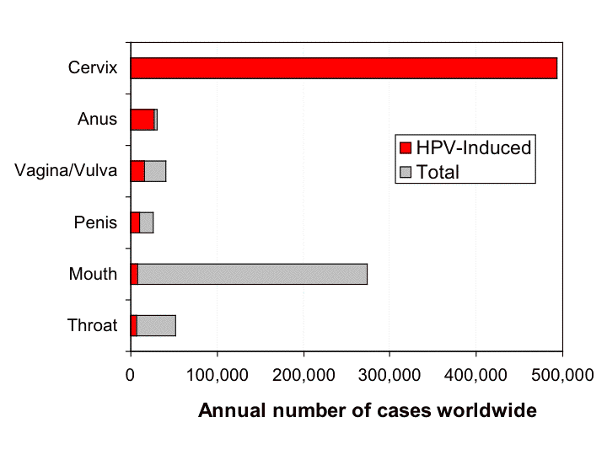
Virtually all cases of cervical cancer are caused by HPV infections

What are the causes of HPV infection?
The HPV virus, typically, enters the human body through a small cut, tear, or abrasion on the epidermis (outermost layer of skin). Experts say the primary mode of transmission is through skin-to-skin contact.
Genital HPV transmission occurs through sexual intercourse, including vaginal and anal sex.
Oral sex may lead to infection in the oral and respiratory regions.
A mother can transmit HPV to her baby during childbirth, but this is rare. When it occurs, the offspring's upper respiratory system or genitals may become infected.
Sharing of contaminated objects is a much less common way of transmission of HPV from one person to another. Although possible, finger-genital contact is a possible way of transmission, but not a major one.

What are the risk factors of HPV infection?
Sexual lifestyle - the more sexual partners people have, the greater their likelihood of becoming infected with HPV. Sexual intercourse with a partner who has had sex with several people also raises the risk.
Young age - children and teenagers are more susceptible to common warts. Although plantar warts may affect adults, they are more common in kids. Teenagers and young adults are more likely to develop genital warts.
Compromised immune systems - people whose immune systems are weak have a greater chance of becoming infected with HPV. Examples are patients who are HIV-positive, organ transplant recipients who are taking immunosuppressive medications, those receiving chemotherapy, and diabetes patients who do not control their disease properly.
Skin lesions - if your skin has tears, cuts or lesions, you are more likely to become infected. If you regularly bite your fingernails there is a higher risk of developing warts around the nails.

Diagnosing HPV infection
A doctor can make a diagnosis if warts are seen in the genital area during a physical examination.
If the doctor does not find any lesions or warts, the following diagnostic tests may be ordered:
- Pap test - a sample of cervical cells or vaginal cells is collected and sent to the lab. This test can determine whether the cells have changed their structure (become abnormal). Abnormal cells usually means there is a higher risk of developing cancer.

- DNA test - this test detects whether high-risk HPV varieties are present; the ones that are associated with genital cancer risk. Some cells from the cervix are taken and sent to the lab for analysis. A study found that the DNA test is best for women over the age of 30 years. (Link to article)

- Vinegar solution test - a vinegar solution is applied to the genital area. If there is an HPV-infection, the areas will turn white. Some flat lesions are hard to detect; this test helps the doctor in his/her diagnosis.
Even though testing for HPV DNA in other types of infections is possible, there are no currently FDA-approved tests for general screening in the USA, neither are there any in Canada, because existing tests are said to be inconclusive and medically unnecessary.

What are the treatment options for HPV infection?
There is no treatment today specifically and solely for HPV infection. In most cases, however, the majority of infections clear up by themselves. Some experts believe total elimination by the immune system does not occur, it just becomes undetectable. Whether or not in such cases the individual is still infectious is hard to know for certain.
The following medications or surgical interventions are sometimes prescribed/used for patients with HPV infections:
- Salicylic acid - some medications gradually remove the warts, one layer at a time. They can be bought without a prescription; they are OTC (over-the-counter) medications. They should not be used for genital warts as they may irritate.

- Trichloroacetic acid - this drug burns off the warts in the genital area.

- Podofilox (Condylox) - used for the treatment of genital warts. A prescription will be required.

- Imiquimod (Aldara, Zyclara) - a topical cream that requires a prescription. Used for the treatment of genital warts.

- Cryotherapy - the warts are frozen with liquid nitrogen. They freeze and fall off.

- Laser surgery - the warts are removed by burning them.

- Surgery - the doctor cuts the warts out.

- Electrocautery - an electrical current is used to "zap" (burn off) warts or lesions

Prevention of HPV infection
Common warts are hard to avoid. Health care professionals say that biting fingernails increases the risk, so not biting them logically reduces the risk.
Plantar warts, which affect the feet, may be prevented by keeping the feet clean and dry. Wearing clean socks and not walking around public swimming pools and sports locker rooms in bare feet may also help.
Genital warts are much less likely to occur among people who are faithful to their sexual partner (and the partner is not infected), do not have many sexual partners, and use latex condoms during sex. Latex condoms help reduce the risk of infection - but there is still a risk.

HPV vaccination
USA - the National Advisory Committee on Immunization Practices says boys and girls aged 11 and 12 years should be routinely vaccinated. For those who have not been fully vaccinated at 11-12 years of age, the Committee says females up to the age of 26 and males up to 21 should be vaccinated. Older males, up to the age of 26, may be vaccinated if they ask for it.
Experts say that HPV vaccines are more effective if given to people before they become sexually active.
The American Academy of Pediatrics, in February 2012, said that boys should be routinely vaccinated against HPV. (Link to article)
U.K. - There has been a national program in the United Kingdom to routinely vaccinate girls aged 12-13 years. A three-year "catch-up" program was started in 2008, to offer the HPV vaccine to girls aged 14-17. Vaccinations are carried out through secondary schools and consist of three jabs that ideally should be administered over a six-month period. It is possible to complete the 3-jab course over a 12-month period.
Two HPV vaccines on the market
There are two vaccines that are currently on the market for HPV:
- Gardasil (Merck & Co.) - also known as Gardisil or Silgard. Designed to protect against HPV types 6, 11, 16 and 18. Types 6 and 11 are thought to cause about 90% of cases of genital warts.

- Cervarix (GlaxoSmithKline) - designed to protect against HPV types 16 and 18, which cause approximately 70% of all cases of cervical cancer. Also, some cross-reactive protection against HPV types 45 and 31 (according to clinical trials). Cervarix also contains a proprietary adjuvant that boosts the immune system response for a longer period (called AS04). Cervarix also offers strong protection against anal cancer. (Link to article)
Vaccinations do not treat existing HPV infections. However, health authorities recommend that HPV-positive people receive the vaccine, because it may protect against other strains.
Gardasil is the vaccine of choice in the USA, while in the UK it is Cervarix. However, as from September, 2012, Gardasil will take over because of its added protection against genital warts.
Globally, cervical cancer is the second most common cancer in women, and the fifth deadliest. In 2008, en estimated 473,000 women developed cervical cancer, and 253,500 died of the disease. If every female were vaccinated against the HPV virus, hundreds of thousands of lives each year would be saved.

